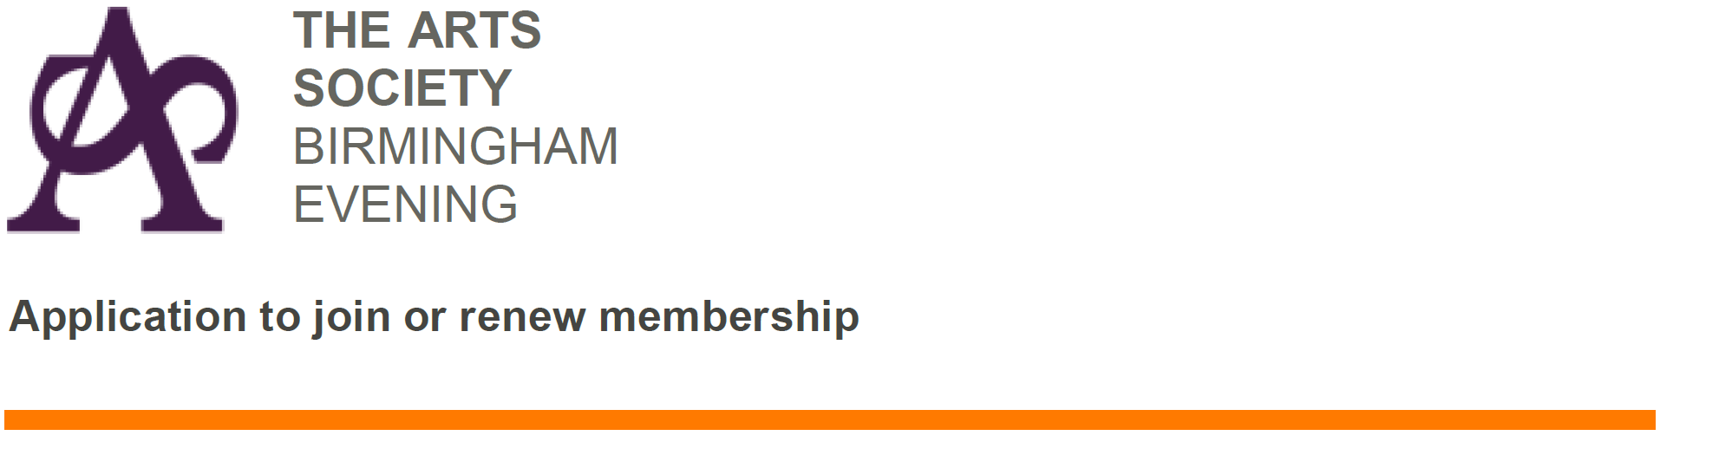
I wish to be a member of The Arts Society Birmingham Evening during 2021 and the national organisation, The Arts Society.

My contact details are:

Title: | First Name: | Surname:
Address:

Postcode:

Email:

Signature: |  | Telephone:

I would / would not be interested in playing a part in running the Society (delete as appropriate).

I consent to my contact details being held by The Arts Society Birmingham Evening in accordance with its Privacy Policy, which is available on our website www.tasbe.org

Payment:
I wish to pay my subscription for 2021 of £60 by Cheque / Internet Banking (delete as appropriate).
Subscriptions for 2021 should be paid by 1st February 2021 or on the date you join the Society.

Internet Banking payments should be made to -
- Account Number: 45091660
- Sort Code: 77-85-21
- Ref: Your initials and surname

Cheques should be made payable to The Arts Society Birmingham Evening or TASBE

This Membership Application Form
In all cases (whether you pay by internet or cheque) this completed form (together with your cheque if appropriate) should be sent, together with a Stamped Self Addressed Envelope enabling us to send you your Membership Card, to -
Mrs Lisa Gillespie
11 Pinfield Drive
Barnt Green
Nr Birmingham B45 8XA.

Thank you for renewing your membership of the Society for 2021 or for becoming a new member.
The Committee hopes you enjoy the programme of lectures, both ‘real’ and ‘virtual’, and other events to be arranged as soon as the Covid restrictions are lifted.

